Implementing PhpRbac
PhpRbac is an OWASP suggested PHP role-based access control package. It is simple to implement and deploy, however it requires its own tables in the database. Ensure you can verify the existence of the necessary tables in place for your blog software.
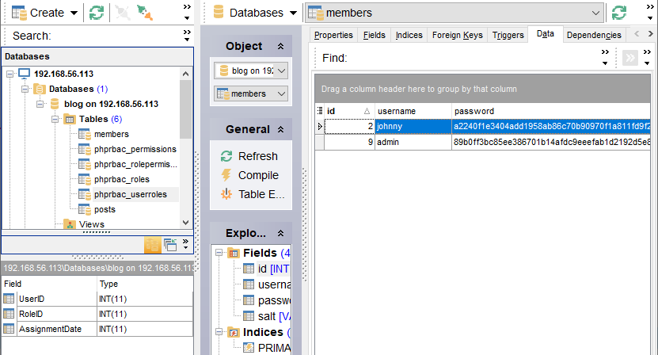
You will also need to config the PhpRbac/database/database.config file with the correct credentials, and to use PDO to connect to our database.
Once you have the tables created, and the configuration saved, you will need to make a quick change on the session information you have from the login page.
You also need to add an account to your database. I added admin above, use your registration page.
Modify your login page so it has the following code, identified by the bold.
$select_sql = "SELECT id, password, salt FROM members WHERE username=:username;";
. . .
session_start();
$_SESSION['username'] = $_POST['username'];
$_SESSION['userid'] = $pass['id']; // add user ID to session info
header("Refresh:5; url=index.php", true, 303);
echo "You have successfully logged in";

Setting up Permissions, Roles, and Users in PhpRbac RUN THIS ONLY ONCE
Now we have our table set up and have captured the user ID as a session variable, we can start configuring users in the database to have specific rolls. For this demonstration, we will only create one permission, admin, one roll, again admin, and assign a new user to this role. I am making the user ID admin as well, but you can assign this to any ID you prefer. Create the user you wish to use, or identify them from your table, and run the following script (I call phprbac.php, but you can call it whatever you wish). YOU ONLY RUN THIS ONCE.
<?php
ob_start();
session_start();
require 'config.php';
require 'database.php';
$g_title = BLOG_NAME . ' - Logout';
$g_page = 'logout';
require 'header.php';
require 'menu.php';
$posts = find_all_blogs(BLOG_INDEX_NUM_POSTS);
require_once 'PhpRbac/autoload.php';
use PhpRbac\Rbac;
$rbac = new Rbac();
// Create a Permission
$perm_id = $rbac->Permissions->add('admin', 'Administer Site');

// Create a Role
$role_id = $rbac->Roles->add('admin', 'Administrator');
// Create Role/Permission Association
// We don't need to query as we just set the variables above, but for reuse in the
// future, we query the IDs from the database
$perm_id = $rbac->Permissions->returnId('admin');
$role_id = $rbac->Roles->returnId('admin');
// The following are equivalent statements
// $rbac->Permissions->assign($role_id, $perm_id);
$rbac->Roles->assign($role_id, $perm_id);

// Assign Role to User (The UserID is provided by the application's User Management System)
// for my system, my admin ID is 15, you will have to retrieve your ID
$rbac->Users->assign($role_id, 15);
?>

<div id="all_blogs">
<table width="300" border="0" cellpadding="0" cellspacing="1" >
<tr>
<td>You have successfully created admin roles</td>
</tr>
</table></div>
<?php
require 'footer.php';
?>
You can add the permissions, roles and user roll relationships manually, but as we might be doing this programmatically in the future, I have included the code above.
Manually run the URL above, and verify the permissions, rolls and relationships have been created in your database:
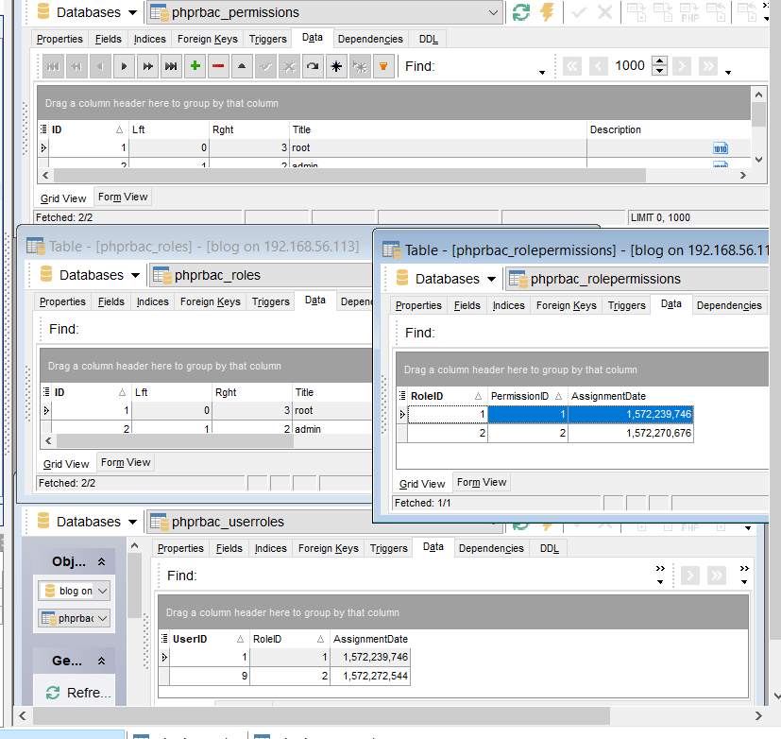
Once you have done the above, you can start adding PhpRbac to your blog application. We will assume you have deployed it as a subdirectory in your blog app going forward.
Each page using PhpRbac should have the following at the top of each page:
use PhpRbac\Rbac;
$rbac = new Rbac();

We also need to load the autoload.php file from PhpRbac. We need only do this once, and it should be done from a page that gets loaded from all pages. We can do this from menu.php. This also gives the chance to set up our navigation to display menu items based on either our ID, or our RBAC authorization. Consider the edits highlighted below:
<?php
require_once 'PhpRbac/autoload.php';
if (!isset($g_page)) {
$g_page = '';
}
use PhpRbac\Rbac;
$rbac = new Rbac();
$role_id = $rbac->Roles->returnId('admin');
?>
<ul id="menu">
<li><a href="index.php" <?= ($g_page == 'index') ? "class='active'" : '' ?>>Home</a></li>
<li><a href="create.php" <?= ($g_page == 'create') ? "class='active'" : '' ?>>New Post</a></li>
<?php
if (isset($_SESSION['username'])) {
?>
<li><a href="logout.php" <?= ($g_page == 'logout') ? "class='active'" : '' ?>>Logout</a></li>
<?php
} else {
?>
<li><a href="login.php" <?= ($g_page == 'login') ? "class='active'" : '' ?>>Login</a></li>
<li><a href="register.php" <?= ($g_page == 'register') ? "class='active'" : '' ?>>Register</a></li>
<?php }
if (isset($_SESSION['username']) && $rbac->Users->hasRole($role_id, $_SESSION['userid'])){
?>
<li><a href="admin.php" <?= ($g_page == 'admin') ? "class='active'" : '' ?>>Admin</a></li>
<?php
}
?></ul> <!-- END div id="menu" -->

Test Access Control
Now we have created the necessary components, we should test it. Add the following code to a page called admin.php (or whatever you prefer)
<?php
ob_start();
session_start();
require 'config.php';
require 'database.php';
$g_title = BLOG_NAME . ' - Admin';
$g_page = 'admin';
require 'header.php';
require 'menu.php';

use PhpRbac\Rbac;
$rbac = new Rbac();

// Get Role Id
$role_id = $rbac->Roles->returnId('admin');

// Make sure User has 'forum_user' Role
if ($rbac->Users->hasRole($role_id, $_SESSION['userid']))
{
$var_testoutput="<p>You are admin, and should be here.</p>";
}
else
{
$var_testoutput="<h2>You should not be here!</h2>";
}

?>

<div id="all_blogs">
<table width="300" border="0" cellpadding="0" cellspacing="1" >
<tr>
<td>

This is the Admin page

<?php echo $var_testoutput; ?>
</td>
</tr>
</table></div>
<?php
require 'footer.php';
?>

The above merely ensures the site can be tested. The test involves using two scenarios – first log in to the site and see if you see the message below:
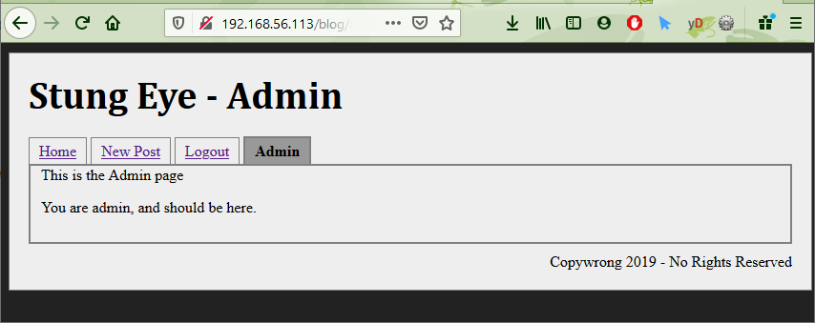
Log out, and log in as someone who isn’t an admin, and you shouldn’t see the admin link in the menu. Manually navigate to the page (blog/admin.php), and you should see the warning below:
